Payroll system

Implementation Planning

Lastest Version

**04/23/2023**

VERSION HISTORY

|  |  |  |  |  |  |
| --- | --- | --- | --- | --- | --- |
| **Version #** | **Implemented**  **By** | **Revision**  **Date** | **Approved**  **By** | **Approval**  **Date** | **Reason** |
| Lastest | Thanh Pham | 04/23/23 | CEO | 04/23/23 | Implement new system |
| Lastest | Muhammad Qamar | 04/23/23 | CEO | 04/23/23 | Implement new system |
|  |  |  |  |  |  |
|  |  |  |  |  |  |

TABLE OF CONTENTS

1 Introduction 5

1.1 Purpose of Implementation Planning 5

1.2 Implementation Objectives 5

1.3 Assumptions 5

1.4 Constraints 5

2 Planning 5

2.1 Roles and Responsibilities 5

2.2 Workforce Changes 5

2.3 Employee Transition 6

2.4 Business Process 6

2.5 Technology Requirements 6

2.6 Communication Approach 6

2.7 Data Conversion Approach 6

2.8 Verification and Validation 6

3 Implementing 6

3.1 Roles and Responsibilities 6

3.2 Workforce Changes 6

3.3 Employee Transition 6

3.4 Business Process 6

3.5 Technology Requirements 7

3.6 Data Conversion 7

3.7 Verification and Validation 7

4 Transitioning 7

4.1 Training 7

4.2 Technical Document 7

Appendix A: Implementation Planning approval 8

APPENDIX B: REFERENCES 9

APPENDIX C: KEY TERMS 10

# Introduction

## Purpose of Implementation Planning

**The purpose of Implementation Planning for a Payroll System** is to create a clear roadmap and optimized framework for implementing the system successfully. During the project there are a lot of specific steps such as defining specific tasks, timelines, resources, and responsibilities required to achieve the project's objectives. Besides, implementation planning also supports finding out potential risks and challenges that may arise during the implementation process and developing strategies for mitigating them.

**The intended audience of the** **Payroll System** may include project managers, development teams, IT Staff, HR Staff, end-users, stakeholders, and any other individuals or teams involved in the implementation process.

**The Objective of Implementation Planning for a Payroll System** includes defining tasks, timelines, resources, and responsibilities needed for a smooth implementation. Also, avoiding disruption while processing operations.

**Potential Benefits:**

* Save the company money by cutting down on labor.
* Make it easier to add information to the database.
* Improve Employee Satisfaction.
* Reducing errors and inaccuracies in payroll.

## Assumptions

* The user has basic computer skills and knowledge of payroll processes.
* The company has the hardware requirements.
* The company has maintained access to the internet.
* The Payroll data provided by the company is 100% accurate and complete.

## Constraints

* The implementation process does not disrupt business operation or significant downtime.
* The system must comply with relevant regulations and legals requirements such as Tax Law and Data Protection Privacy regulations.
* The system must be scalable and approachable to future growth and changes in the organization’s needs.
* The system must integrate smoothly with other existing systems and technologies.
* The budget for Implementation and ongoing maintenance must be considered.

# Planning

The **Payroll System** will be planned out in stages. First it will be passed off to the developers, then the alpha test and editing team, then to the beta testers. Then the lead developers will finish and release the production version.

## Roles and Responsibilities

**Thanh Pham** Roles and Responsibilities:

* **Project Manager**: Control the entire implementation process, including planning, asigning task to another member in designing interface, testing and deployment the Payroll System.
* **Database Administrator**: Responsible for database design and management of the Payroll System.
* **Data Engineer:** Cleaning andensuring the security, accuracy, and integrity of data.

**Muhammad Qamar** Roles and Responsibilities:

* **Developer**: Responsible for designing and developing the payroll system based on the project requirements and specifications.
  + Designing Interface of the system.
  + Handling other requirements such as testing and deployment of the system.
  + Maintaining the system*.*

## Workforce Changes

Because there is System for the whole company so it may have some changes below:

* The HR department will be in charge most of controlling the new system.
* The Finance department also must provide necessary data during the implementation process.
* This process should concern making sure these departments can allocate important resources.

## Employee Transition

Providing necessary training and support to all employees to ensure they can adapt with new the new Payroll System. This “Transition” included:

* Training sessions (provide PowerPoint or slides about the new system from basis to advanced)
* Having Q/A section for employees to ask.

## Business Process

*Changing the system from manual to automated system. Below is the database system design:*

## Technology ReQUIREMENTS

* *Database Management System (DBSM).*
* *Payroll software system.*
* *Computer Hardware (Servers, Workstations, and Printer).*
* *Operating System Software (Windows).*
* *Networking Equipment (Router, Switches and Firewalls).*
* *Cloud Computing Services for Backup and Recovery Data (Azure, AWS and Google Cloud).*
* *Software development tools (e.g., Integrated Development Environment, code editors).*
* *User authentication and access controll software.*

## Communication Approach

The communication approach for the implementation of the new Payroll System will include regular meetings and updates with all stakeholders involved. This may involve:

1. Kick of meeting to introduce about project:
   1. Outlines goals
   2. Assign roles and responsibilities
2. Regular Status Update Meeting:
   1. Team will have one day of weekday and two days of weekend to discuss any challenges
   2. Modify project plan if needed
3. Workshop:
   1. Demonstrate new system to employees and allow them to ask questions
   2. Encourage employee to give feedback
   3. Provide Tranning session
4. Final Presentation
   1. Report how the success of the project affects the company
   2. Showcase the new Payroll System

## Data Conversion Approach

The Data Conversion Appoarch is about converting data from Excel to SQL tables and storing them in an Access database. The following steps would be:

* Clarifying the data needed to be converted
* Cleaning data and ensuring accuracy **(Data Enginneer)**
* Converting the data from Excel to SQL format **(Having DML Script for updating, etc..)**
* Storing the converted data in an Access database
* Testing the data conversion to ensure have no error on it

## Verification and Validation

Details on the verification and validation processes for the Payroll System implementation, such as:

* Conduct unit testing to ensure individual system components are working correctly.
* Performing integration testing to verify that the system functions and integrates smoothly with other existing methods.
* Running system testing to evaluate the system's performance, reliability, and scalability under various conditions and scenarios.
* Conduct user acceptance testing (UAT) to ensure the system meets the end-users needs and expectations.
* Setting up a feedback mechanism to receive and address any issues or concerns users raise during testing or after deployment.

# Implementing

Implementing this payroll database is no easy and straightforward plan. This system affects every employee and not only those on a salary wage. This involves taking out the old system and replacing it with the new one, including the clock in machines, biometric features, software upgrades, and maintenance of the overall database.

.

## Roles and Responsibilities

* HR will be responsible for watching over the Payroll system and providing basic knowledge articles to help employees navigate the new system.
* Database Admins will be responsible for maintaining the databases and ensuring information gathered from different departments is safe and securely transitioned into the system.
* Finance/Payroll departments will make sure they have valid financial information on each employee and will ensure each employee is moved to the new system correctly.
* Third Party installers, such as Kronos are needed to install the clock machines throughout the business building, they are also to ensure that each biometric feature on those machines works properly.
* All employees are still responsible for their own timesheets, clock in/out times and ensuring their badge/biometrics are correct and working.

## Workforce Changes

Again, this new system affects all employees regardless of pay grade, in doing so there may be some added workforce changes that make the transition easier:

* Hiring more DBAs will help in maintaining the new payroll database.
* Training Payroll employees on the new system and how it works
* Increasing general IT knowledge for all employees through required training to understand the payroll system and biometrics.

## Employee Transition

With a system this size some departments may have more responsibilities for the first couple phases up until everything is caught up and employees understand how the system works relatively.

1. The Finance department may have a new department that helps with only employee investments. Since the new system does offer investments, it would be helpful to have someone to contact.
2. The database teams may have more workload transitioning all the data from the old system to the new system while still maintaining operations.
3. Making sure that the employees are still paid on time with the correct amount while this transition is happening is key. The goal is to have this whole system prebuilt and then implemented within a two-week time frame but have a buffer if needed.

## Business Process

The business process for this system would be implementing the new software for the Payroll system, below you can see what that may look like.

*This is only a proof of concept*

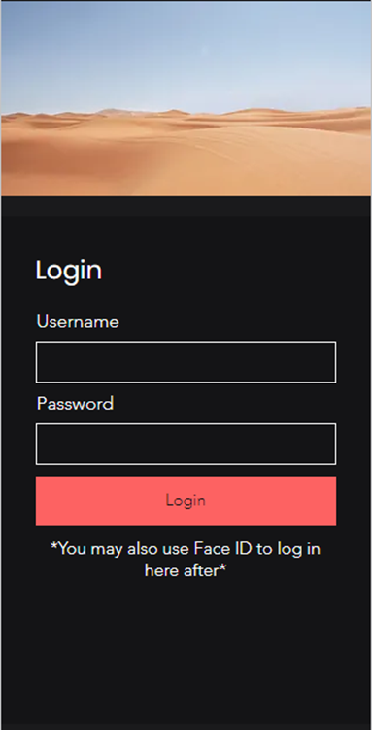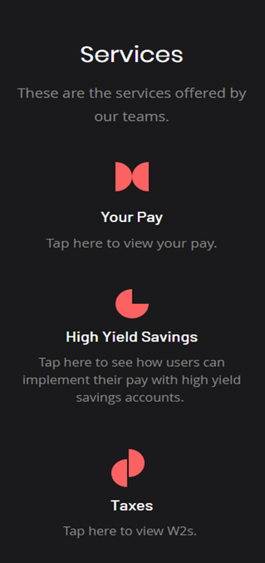

## Technology Requirements

* Kronos clock machines
* Database systems (Oracle, Microsoft SQL, etc.)
* Biometric scanners on Kronos machines
* Finance Helpdesk
* Payroll ticketing system
* Hardware computers, monitors, desks, etc.

## Data Conversion

*The main data conversion for this system would be from excels to databases for example:*

* *User data in Excel > Database such as MySQL, Oracle, etc.*
* *From Database > Payroll System*
* *Once the data is in the payroll system it will be accessible to the perspective employees.*

## Verification and Validation

*The important thing to note is that the main features of the Payroll system involve the correct financials as well as making sure each of the services are properly functioning.*

*To do this, it is important to hire verified database admins and financial consultants. This way if users need help with financial savings, they have someone to contact and if the database is not configured correctly, we have the correct people to do it.*

# Transitioning

In this transition, the most important strategy is to ensure the employees are taken care of with their financials. To do this we have to ensure that the old system is up and running until we are able to seamlessly transition into the new system. This involves making sure the conversion data is transferred successfully, that includes training the support team on all problems that may come up with the payroll system.

Since the support team are the first form of contact for any company, it is important that they have a general knowledge about a broad range of topics or at the very least the correct contact info for each of those departments.

## Training

When implementing a system like this training is crucial:

* Ensuring database admins have the proper tools to do their jobs and any extra training needed.
* Making knowledge articles for all employees so that they understand how the system works
* Training Payroll employees to help with basic financial questions about the system

## Technical Document

The technical documents for this system would include:

* Knowledge articles for all employees
* Financial documents for all employees
* Databases for each department

# Appendix A: Implementation Planning approval

The undersigned acknowledge they have reviewed the Implementation Planning and authorize and fund the Payroll System project. The undersigned herby give the project manager the authority to apply the approved level of organizational resources to project activities. Changes to this Implementation Planning will be coordinated with and approved by the undersigned or their designated representatives.

|  |  |  |  |
| --- | --- | --- | --- |
| Signature: | Daniel Wright | Date: | 4/28/23 |
| Print Name: | Daniel Wright |  |  |
| Title: | Project Manager |  |  |
| Role: | Payroll system project manager |  |  |

|  |  |  |  |
| --- | --- | --- | --- |
| Signature: | Lenny Duncan | Date: | 4/28/23 |
| Print Name: | Lenny Duncan |  |  |
| Title: | Shareholder |  |  |
| Role: | Investments |  |  |
|  |  |  |  |
|  |  |  |  |

|  |  |  |  |
| --- | --- | --- | --- |
| Signature: | Ken Times | Date: | 4/28/23 |
| Print Name: | Ken Times |  |  |
| Title: | VP Payroll |  |  |
| Role: | Ensuring the system roll out |  |  |

APPENDIX B: REFERENCES

The following table summarizes the documents referenced in this document.

|  |  |  |
| --- | --- | --- |
| **Document Name and Version** | **Description** | **Location** |
| System Requirement Document | Requirements for the Payroll system. | Oklahoma City, OK |
| System Architecture Plan | Overall system plan | Oklahoma City, OK |

APPENDIX C: KEY TERMS

The following table provides definitions for terms relevant to this document.

|  |  |
| --- | --- |
| **Term** | **Definition** |
| *DBSM* | *Database System Management* |
| *AWS* | *Amazon Web Services* |
| *Kronos* | *Clock in machine* |